Class 1

## Dot Product

Let be in . The scalar product or the dot product is given by:



## General Inner Products

**Definition:** Let be a vector space, a mapping such that:

* , and ;



* , and (bilinear mapping);



* positive definite);



* (symmetric).



## Lengths and Distances

### Lengths

Let , by Pythagoras



the length of is

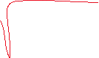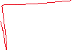

We can define a norm through the inner product

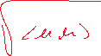

However, not every norm is induced by an inner product.

### Distance

* 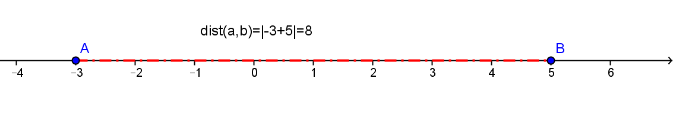 :

:

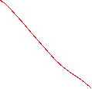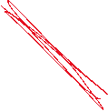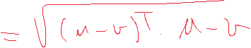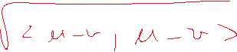

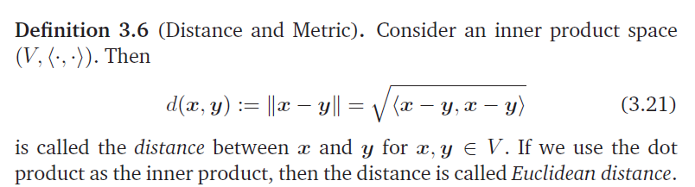

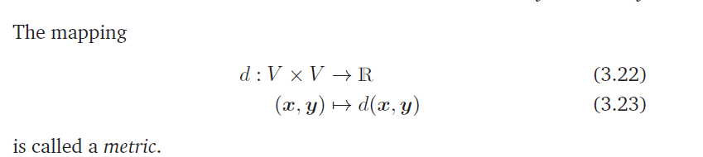

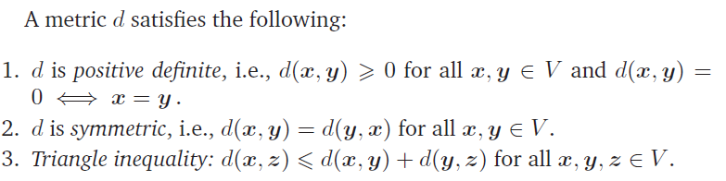

# Orthogonality

## 1.2.1 Angles

**Definition** Let be vectors in or then



|  |  |
| --- | --- |
| Let us compute the angle between, and .  Hence |  |



## 1.2.2 Orthogonal vectors

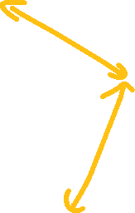

, but



Then , if and only if se .



**Definition 3.7** (Orthogonality). Two vectors x and y are orthogonal if and only if



x and y are *orthonormal if* additionally



**Let us see that the following vectors ,* are orthonormal?***

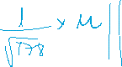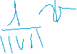

* An implication of this definition is that the 0-vector is orthogonal to every vector in the vector space.
* Orthogonality is the generalization of the concept of perpendicularity to bilinear forms that do not have to be the dot product. In our context, geometrically, we can think of orthogonal vectors as having a right angle with respect to a specific inner product.

**Definition 3.8** (Orthogonal Matrix) A square matrix A is an *orthogonal matrix* if and only if its columns are orthonormal

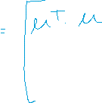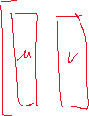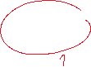

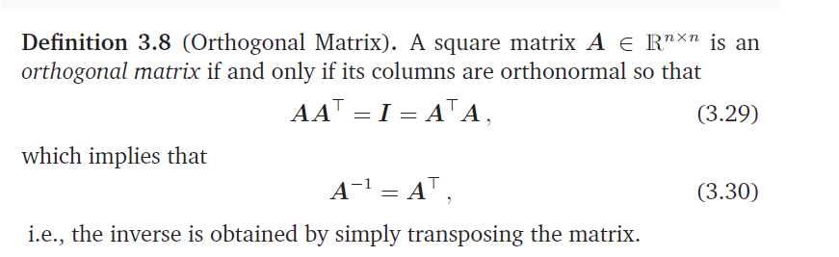

**Example:**

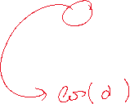

|  |  |
| --- | --- |
|  |  |

* Transformations by orthogonal matrices are special because the length of a vector x is not changed when transforming it using an orthogonal matrix A.



* the angle between any two vectors x; y, as measured by their inner product, is also unchanged when transforming both of them using an orthogonal matrix A



- angle between the transformed vectors

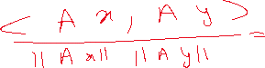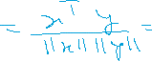

## REVIEWS

As another illustration of how subtle words are, there are (at least) three different ways to think about vectors: a vector as an array of numbers (a computer science view), a vector as an arrow with a direction and magnitude (a physics view), and a vector as an object that obeys addition and scaling (a mathematical view).

* A vector space can be many bases, but all bases possess the same number of elements.
* Dimension of a vector space
* Dimension subspaces

If is a subspace of , them .

* if and only if .
* if and only if .

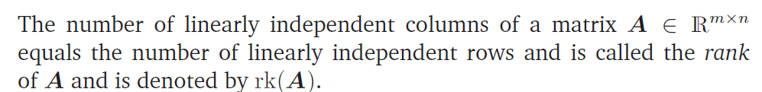

## 1.2.3 Orthonormal Basis



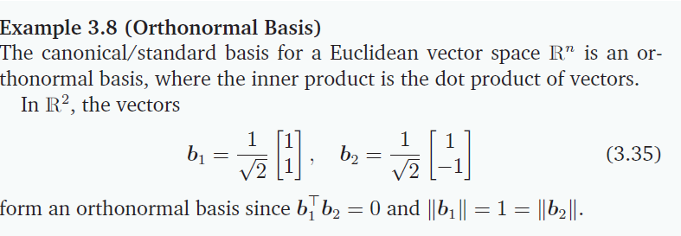

## 1.2.4 Orthogonal Complement

The orthogonal complement of a vector subspace, S , of V, denoted by  is the set of all vectors that are orthogonal to all elements of S, that is:



**Theorem**



Let a subspace of such that then

* if and only if , forall
* is a subspace
* .
* , with and

Consider the plane in ?

